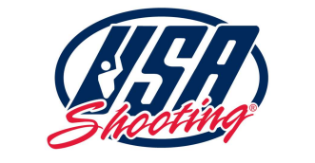

USA Shooting

Board of Directors Quarterly Board Meeting

Tuesday, May 6, 2025

9am PST / 10am MT / 11am CST / 12pm ET

Held via Zoom

\*\*After the call to order: all times are approximate.\*\*

10:00 am MT

Call to Order Tim Rupli, Chair

10:03 am - 1:10 PM MT

Roll Call, Establish Quorum Laura Peters, Counsel

Conflict of Interest Declarations Laura Peters, Counsel

10:10 am MT

Approval of the Minutes Jack Burch, Secretary

CEO Update Kelly Reisdorf, CEO

Financials

World Cups & Selection Processes

High Performance

USAS Events

Chairman’s Report Tim Rupli, Chair

Treasurer’s Report Sara Walker, Treasurer

Athlete Rep Report Dania Vizzi

ISSF Update Kim Rhode

LA 2028 Update Kelly Reisdorf & Kim Rhode

USOPC Onboarding Jim Byrne

Committee Schedule Tim Rupli, Chair

Ranking System Update Michael Chubb

11:30 am MT

Executive Session Tim Rupli, Chair

1:00 pm MT

Adjourn Meeting Tim Rupli, Chair